26 November 2024

TITAN Digital Accelerator: Digital innovation
for the industrial sector
“TITAN Digital Accelerator” initiative is the result of TITAN Group’s collaboration
with the Centre for Research & Technology Hellas and the International Hellenic University,
promoting applied research for digital solutions in the industry of building materials’ solutions.
During an event held in Thessaloniki, TITAN Group, in collaboration with the Centre for Research & Technology Hellas (CERTH) and the International Hellenic University (IHU), announced the establishment of “TITAN Digital Accelerator”, an initiative based in the city and aimed to accelerate the development of innovative digital solutions and tools that can transform the industry of building materials’ solutions.
Focusing on dynamic areas of digital technology, such as the Internet of Things, digital twins, robotics, and cybersecurity, and coupling them with the use of Artificial Intelligence, this initiative will create significant benefits not only for its three partners, but also for the wider industrial sector and the research and innovation ecosystem.
At the same time, leveraging the power of synergy among one of the internationally top providers of building materials’ solutions, one of the biggest research bodies in Northern Greece and one of the most prominent tertiary education institutions, the initiative in question further reinforces the role of Thessaloniki as a digital innovation hub in Southeast Europe. At the national level too, “TITAN Digital Accelerator” underlines Greece’s orientation to innovation and extroversion, demonstrating that our country has highly skilled human resources, who can create and support a knowledge-based economy.
“TITAN Digital Accelerator” is staffed by a highly trained and specialized workforce based in Thessaloniki.
The costs necessary for the establishment of “TITAN Digital Accelerator” have been undertaken by TITAN Group, which is also financing its operation, with a significant investment. In turn, CERTH and IHU, in addition to access to the research and technology ecosystem, contribute by providing state-of-the-art infrastructure, including the premises that house “TITAN Digital Accelerator”, laboratories, and equipment.
All three partners are working together to create an ever-renewing portfolio of projects for evaluation. TITAN Group, based on market trends and needs, is designing and financing the roadmap for the implementation of the highest priority projects, making the most of the potential of "TITAN Digital Accelerator" staff. At least five projects will be implemented within the first year of operation of “TITAN Digital Accelerator”, with more to follow in the coming years. Among them stand out projects that include the use of robots, drones and GenAI in the inspection and technical maintenance of industrial equipment, as well as the development of a series of digital tools aimed at automating and improving manufacturing processes, as well as the entire logistics chain and customer experience.
Commenting on the establishment of “TITAN Digital Accelerator”, TITAN Group’s Chief Digital and Strategy Officer Antonios Kyrkos mentioned: “The establishment of ‘TITAN Digital Accelerator’ in Thessaloniki marks an important step forward in the Group’s digital transformation strategy, which further strengthens our position at the forefront of digital innovation in the global cement industry. However, what gives us even greater joy is that, through this initiative and our collaboration with two of the country’s leading research institutions, we are contributing in yet another way to Greece’s shift towards innovation and extroversion and to the promotion of its human resources’ talent. We look forward to seeing ‘TITAN Digital Accelerator’ become the birthplace of projects that will revolutionize the way we build.”
For his part, the Chair of CERTH’s Board of Directors Dr. Dimitrios Tzovaras stated: “Embarking on this partnership, we respond to the undeniable need to deepen the links between research and the market, making available to TITAN Group not only the high-quality research infrastructure of CERTH, through two laboratories of CERTH|ITI (CERTH Information Technologies Institute), but also the expertise of our researchers in developing innovative digital solutions in a wide range of critical areas of digital technology. Our shared vision to promote innovation increases our joy in our collaboration with TITAN Group.”
In turn, the Rector of the International University of Greece Professor Stamatis Angelopoulos noted: “It is our honor and responsibility to contribute to the “TITAN Digital Accelerator” initiative, a partnership with TITAN Group and the Centre for Research & Technology Hellas (CERTH), which embodies our University's dedication to promoting innovation and research. This project, based in Thessaloniki, promotes the interconnection of the university community with industry, opening new horizons for the implementation of innovative digital solutions in the field of building materials. At the same time, it is a shining example of how synergy between entities with a common vision and goals can strengthen the national economy and contribute to the development of a knowledge-based society.”
The event was honored by the Vice-Regional Governor of ME Thessaloniki Mr. Konstantinos Youtikas, the Central Macedonia Deputy Regional Governor for Infrastructure and Networks Mr. Paris Billias, the Central Macedonia Deputy Governor of Digital Governance Mr. Nikolaos Jollas, and the Mayor of Pavlos Melas Mr. Dimitris Aslanidis.

Appendix: Indicative projects already in the pipeline
Project 1: Robotic inspection of kiln
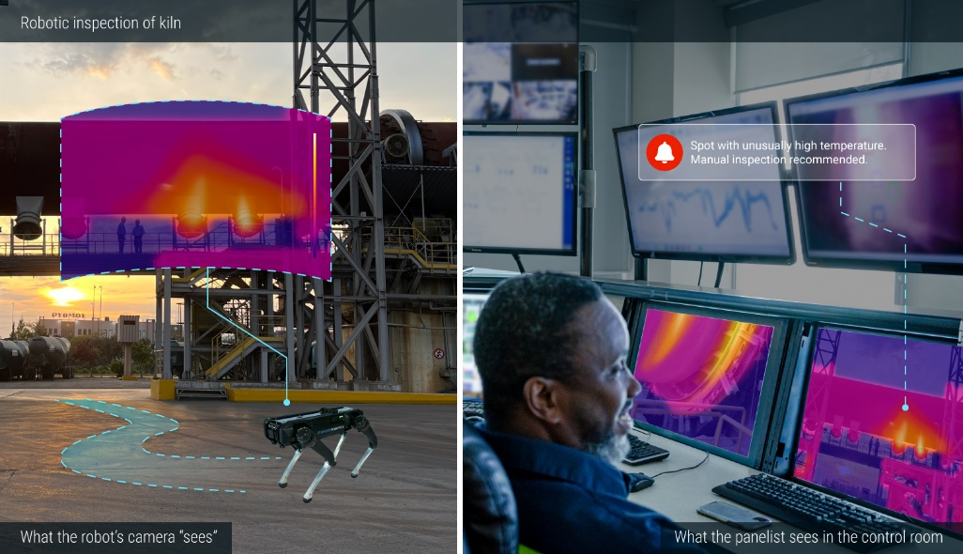
A four-legged robot is used to monitor and inspect industrial equipment, such as the kiln and the pre-heater tower. Equipped with a thermal camera, the robot can quickly identify unusual temperature changes that might signal potential issues. It also uses a microphone to detect potential air leaks. By spotting such potential issues early, the plant can reduce maintenance costs and ensure smoother, more efficient operations.
Project 2: Drone inspection of the preheater tower
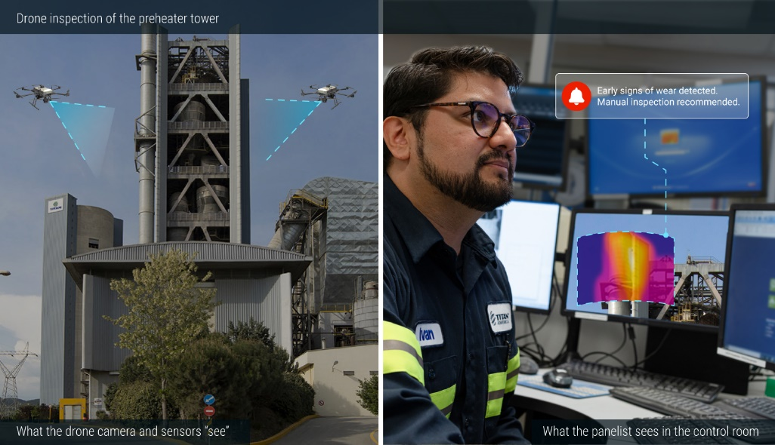
Drones equipped with high-resolution cameras and infrared sensors are used to inspect machinery at elevated locations, such as cranes, silos, and conveyors. These drones can detect early signs of wear, overheating, or misalignment in hard-to-reach equipment, enabling predictive maintenance. This proactive approach extends the lifespan of machinery, minimizes the possibility of issues in equipment, and reduces the need for manual inspections at height.
About TITAN Group
TITAN Group is a leading international business in the building and infrastructure materials industry, with passionate teams committed to providing innovative solutions for a better world. With most of its activity in the developed markets, the Group employs over 5,700 people and is present in over 25 countries, holding prominent positions in the US, Europe, including Greece, the Balkans, and the Eastern Mediterranean. The Group also has a joint venture in Brazil. With a 120-year history, TITAN has always fostered a family-and entrepreneurial-oriented culture for its employees and works tirelessly with its customers to meet the modern needs of society while promoting sustainable growth with responsibility and integrity. TITAN has set a net-zero goal for 2050 and has its CO₂ reduction targets validated by the Science Based Targets initiative (SBTi). The company is listed on Euronext and the Athens Exchange. For more information, visit our website at www.titan-cement.com.
About the Centre for Research and Technology Hellas
The Centre for Research and Technology Hellas is a leading Research Centre of scientific excellence that stands at the forefront of technological research, through its dedication to promoting innovative research for the benefit of society. It was founded in March 2000, as a legal entity governed by private law with non-profit status. Its main services are located in Thessaloniki. The spectrum of its research activities is wide, extending from artificial intelligence, advanced robotics, and the Internet of Things to clean energy, green hydrogen, autonomous vehicles, holistic approaches for healthcare and nutrition, smart agriculture, and circular economy. It employs more than 1,700 highly qualified researchers, while at the same time emphasizing entrepreneurial growth, as reflected in its 23 spin-off companies that currently operate with intense economic activity, achieving significant progress. CERTH ranks among the top five research organizations in the EU in terms of attracting competitive research grants in the field of Artificial Intelligence between the years 2021 and 2023. In today’s rapidly changing socio-economic environment, CERTH significantly contributes to tackling the modern challenges, creating the conditions for new growth insights and perspectives. For more information, visit our website at www.certh.gr.
About the International Hellenic University
The International Hellenic University, the only public university in the country with facilities in five campuses in Northern Greece, was established under Law 3391/2005 and is based in Thessaloniki. It is the first Greek university to offer graduate programs exclusively in English. The re-establishment of International Hellenic University in 2019, based on Law 4610/2019, has established it as one of the most significant academic institutions in the country. With facilities in Thessaloniki (Thermi and Sindos), as well as in Serres, Kilkis, and Katerini, International Hellenic University comprises eight Schools and 25 Departments, offering a wide range of undergraduate, graduate, and doctoral programs. The University Center for International Study Programs operates exclusively with English-speaking Graduate Programs, attracting talent from the local community as well as the international environment. International Hellenic University aspires to be a beacon of excellence in education and research, emphasizing internationalization, the effective application of research outcomes, innovative teaching and learning practices, the cultivation of entrepreneurship, and a strong connection with society.

